Techno Machine Tools
Survey no:126/A/1, DOOR NO: 4-132-9/A/2, Gandimaisamma X Road,
Medchal Malkajgeri,Hyderabad-500043.Telangana, India.

(Machine tool manufacturers)

T.SIVARAMAKRISHNA
ME. MBA.,
---------------------------------------------------------------------------------------------------------------------------------------------

TMT/HEMAKUMAR/S0223/2025 22.04.2025

To,
HEMAKUMAR,
MOBILE +91 98844 54647

Dear sir,

Sub: - QUOTATION FOR Cut –To-Length

Thank you very much for your inquiry regarding your requirement of Cut-To-Length machine for MS material. We are glade to inform you that we would be in a position to supply you the required equipment. Given below are the required specifications and description of the machine and our terms and conditions.

TECHNICAL SPECIFICATIONS:

Maximum sheet width that can be leveler : 180 MM

Maximum sheet thickness in MS that can be Leveller : 1.5 MM

Minimum sheet thickness in MS that can be Cut : 0.8 MM

Mandrel uncoiler : 1 MT

Speed of the machine : 0-12.0 meters/min

DESCRIPTION OF THE EQUIPMENTS

ENTRY GUIDE

The entry side of slitter head is by means of guide table; guide blocks along with guide rolls. Which will be responsible for centering the leading ends of the sheet in to the first pass.

LEVER AND PINCHROLL

Number of rollers for leveling : 19 Nos

Number of pinch rollers : 2 Nos

Diameter of the roll : dia 45 mm

Load arrangement for leveler : combination gear box

Load arrangement for Pinch roll : manual

Drive : 10 HP with vfd

The lever is with triangular roll attachment along with combination screw down gearbox with manual wheel movement for adjusting the loads. The pinch roll is allowed the strip to move to forward to entry guides.

MANDREL UNCOILER

Coil weight : 1 MT Max

Coil width : 180 MM

Coil bore : dia 500 MM min, 600 MM max

Mandrel Actuation : Manual

Back Tension : Caliper brake, Manually adjusted

Construction : M. S. Fabricated.

Drive motor : 5 Hp

PLC UNIT

The electrical unit is equipped with PLC along with vector drive and the length will be measured with the help of encoder. The length and the number of sheets will be fed for operation of the equipment. The length accuracy is +/_ 0.5 mm and diagonal accuracy is between +/- 1.0 mm.

PRICES

Leveler Unit, Entry guide, shearing unit, along with power pack and other electrical connections is RS 7,77,000=00 ( Rupees Seven Lacks Seventy Seven Thousand Only)

GENERAL TERMS & CONDITIONS:

- Price quoted per unit ex-work. Hyderabad.
- Following charges are additional to your account.
- Freight Charge : As actual to be borne by you.
- Sales Tax : 18% Extra as applicable .
- Packing charge : As actual to be borne by you.
- Insurance : As actual to be borne by you.
- Payment : 50% advance along with order 30% work in progress balance before delivery but after inspection at our works.
- Delivery : Within 8-10 weeks from date of advance received
- Validity : One month from the date of submission.
- Inspection : Inspection at our works prior to dispatch.
- Warranty : The machine is warranted for a period of 12 months from the date of dispatch against any manufacturing defects/ faulty material or bad workmanship of any part or component but not against any kind of abnormal or improper use of machine. Defective part or component will be replaced or repaired free of cost. Electrical components are outside the scope of this warranty.
- Commissioning : Erection & commissioning done by you, but required technical support & guidance provide by us at additional cost.

NOTE:
- Oil is not in scope of our supply.
- Raw material for trial is to be arranged by you at your cost.

We are sure you will find our offer in line with your requirements. Should you require any further clarification please contact 9246221106 email: srktalam@gmail.com

Thanking you and assuring you of our best services

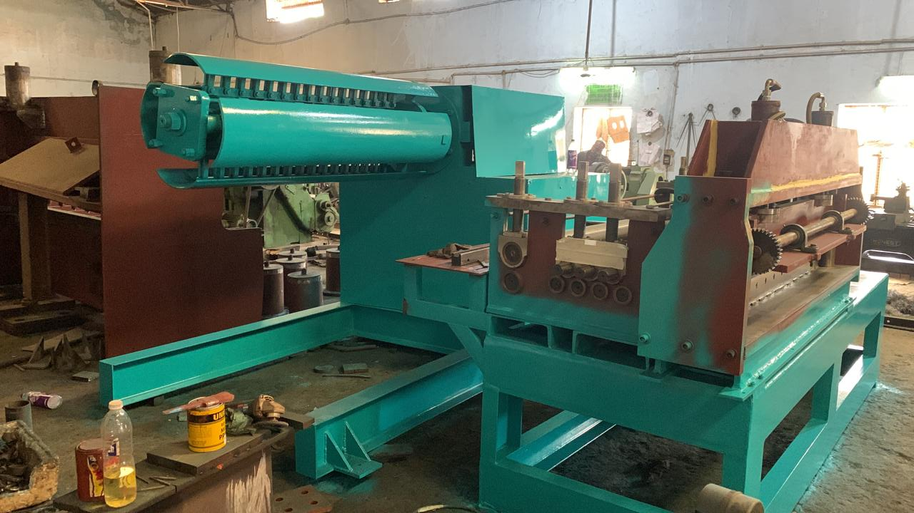

For TECHNO MACHINE TOOLS

( T. SIVARAMAKRISHNA)

